Global Account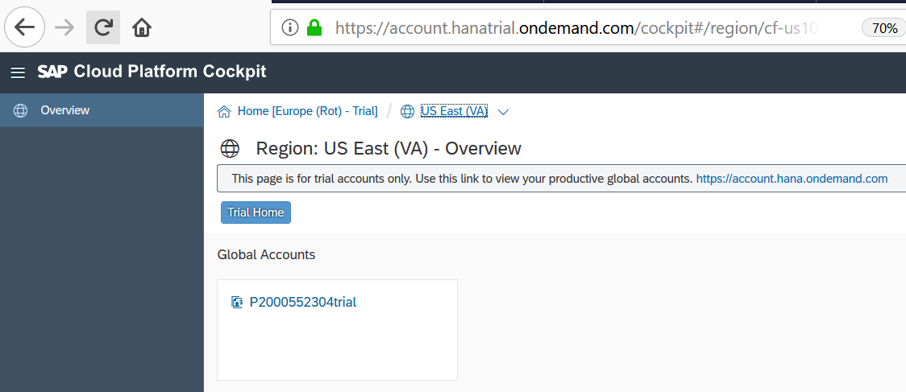

Space

Click on the Global account tile and the subaccount is shown. Choose trial subaccount.

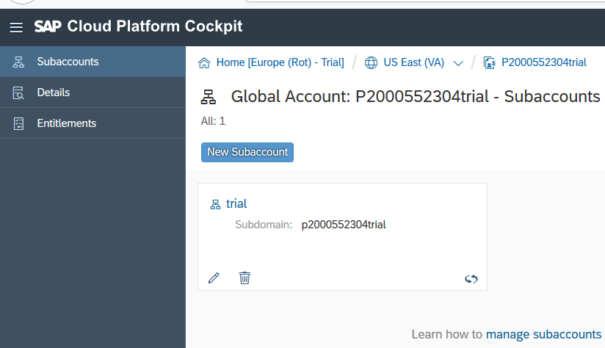

Go to SPACES and choose dev

